Modifying Padawan360 for using an Xbox360 Chatpad

- MAKE A BACKUP OF YOUR WORKING CODE AND SAVE IT SOMEWHERE THAT IT WON’T BE LOST, MODIFIED, OVERWRITTEN OR OTHERWISE CHANGED. If it all goes horribly wrong, you want to be able to load that version of working code!

- In the Arduino Library directory (usually ~/Documents/Arduino/libraries/) create a zipped backup of the standard USB_Host_Shield_2.0 backup and delete the original. If you leave the original copy of this in the library directory alongside the Willtoth version I think you will get an error on compile informing you that there are multiple libraries for XBOXRECV.h.

- Download Willtoth’s fork of the USB_HUB_SHIELD library and unzip it to the Arduino Library directory.

https://github.com/willtoth/USB_Host_Shield_2.0/tree/xbox-chatpad

- Add "#define CHATPAD" before void setup();

Example code:
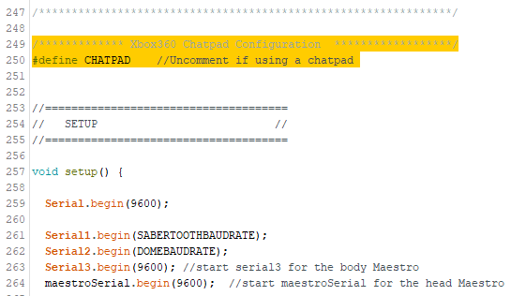

- In main loop, just before all of the “getButtonClick” checks, call function Check_Chatpad() if you have CHATPAD defined

Example code:
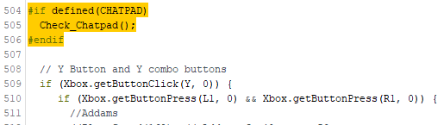

- Create a function Check_Chatpad() to look for chatpad click events. If a particular button is pressed make a sound, flash a light etc.

In this function the Arduino will check for a key click (i.e. press & release) of each chatpad button that you list.

Example code (can be added right at the end of the Padawan Sketch):

void Check_Chatpad() {

if (Xbox.getChatpadClick(XBOX_CHATPAD_D1, 0)) {
//Duel of the Fates
mp3Trigger.play(35); // Duel of Fates 4m 17s
}

if (Xbox.getChatpadClick(XBOX_CHATPAD_D2, 0)) {
//Theme
mp3Trigger.play(30); // Star Wars Theme 5m 29s
}

if (Xbox.getChatpadClick(XBOX_CHATPAD_D3, 0)) {
//Imperial March
mp3Trigger.play(31); // Imperial March 3m 5s
}

if (Xbox.getChatpadClick(XBOX_CHATPAD_D4, 0)) {
//Cantina
mp3Trigger.play(34); // Cantina 2m 50s
}

if (Xbox.getChatpadClick(XBOX_CHATPAD_D5, 0)) {
//Star Wars Rebels Stinger
mp3Trigger.play(32); // Star Wars Rebels Stinger 3s
}

if (Xbox.getChatpadClick(XBOX_CHATPAD_D6, 0)) {
//Star Wars Rebels Theme
mp3Trigger.play(33); // Star Wars Rebels Theme 1m 36s
}

/*
if (Xbox.getChatpadClick(XBOX_CHATPAD_D8, 0)) {
//Muppets
mp3Trigger.play(173); // Muppets Tune 30s
}
*/

if (Xbox.getChatpadClick(XBOX_CHATPAD_D9, 0)) {
// Annoyed
mp3Trigger.play(random(8,10)); // Annoyed
}

if (Xbox.getChatpadClick(XBOX_CHATPAD_D0, 0)) {
//Chatty
mp3Trigger.play(random(25,29)); // Chatty Random sounds
}

if (Xbox.getChatpadClick(XBOX_CHATPAD_W, 0)) {
//WolfWhistle
mp3Trigger.play(36); // Wolf whistle
}

if (Xbox.getChatpadClick(XBOX_CHATPAD_O, 0)) {
//scream
mp3Trigger.play(1); // Scream
}

/*
if (Xbox.getChatpadClick(XBOX_CHATPAD_S, 0)) {
//ohh (Sad Sound)
mp3Trigger.play(random(25, 31)); // ohh (Sad Sound)
}
*/

if (Xbox.getChatpadClick(XBOX_CHATPAD_D, 0)) {
//DOODOO
mp3Trigger.play(15); // DOODOO
}

if (Xbox.getChatpadClick(XBOX_CHATPAD_T, 0)) {
//TaDa
mp3Trigger.play(16); // TaDa
}
/*
if (Xbox.getChatpadClick(XBOX_CHATPAD_L, 0)) {
if (Xbox.getButtonPress(L2 , 0)){
//Luke message
mp3Trigger.play(171); // Luke Message 26s
}
else {
mp3Trigger.play(5); // Leia Long 35s
}
}

if (Xbox.getChatpadClick(XBOX_CHATPAD_P, 0)) {
if (Xbox.getButtonPress(L2 , 0)){
//Periscope Peek
maestrohead.restartScript(3);//Periscope Peek (incl LED
}
else {
//Periscope Full
maestrohead.restartScript(2);//Periscope Look Around (incl LED)
}
}
*/

if (Xbox.getChatpadClick(XBOX_CHATPAD_X, 0)) {
//shortcircuit
mp3Trigger.play(13); // Short Circuit
}

if (Xbox.getChatpadClick(XBOX_CHATPAD_C, 0)) {
//Chortle
mp3Trigger.play(23); // Chortle
}

//Use "SPACE" to stop music and return to random lights
if (Xbox.getChatpadClick(XBOX_CHATPAD_SPACE, 0)) {
//Stop music tracks
mp3Trigger.stop();
}

}

